October 2016 Pumpkin Patch Hours

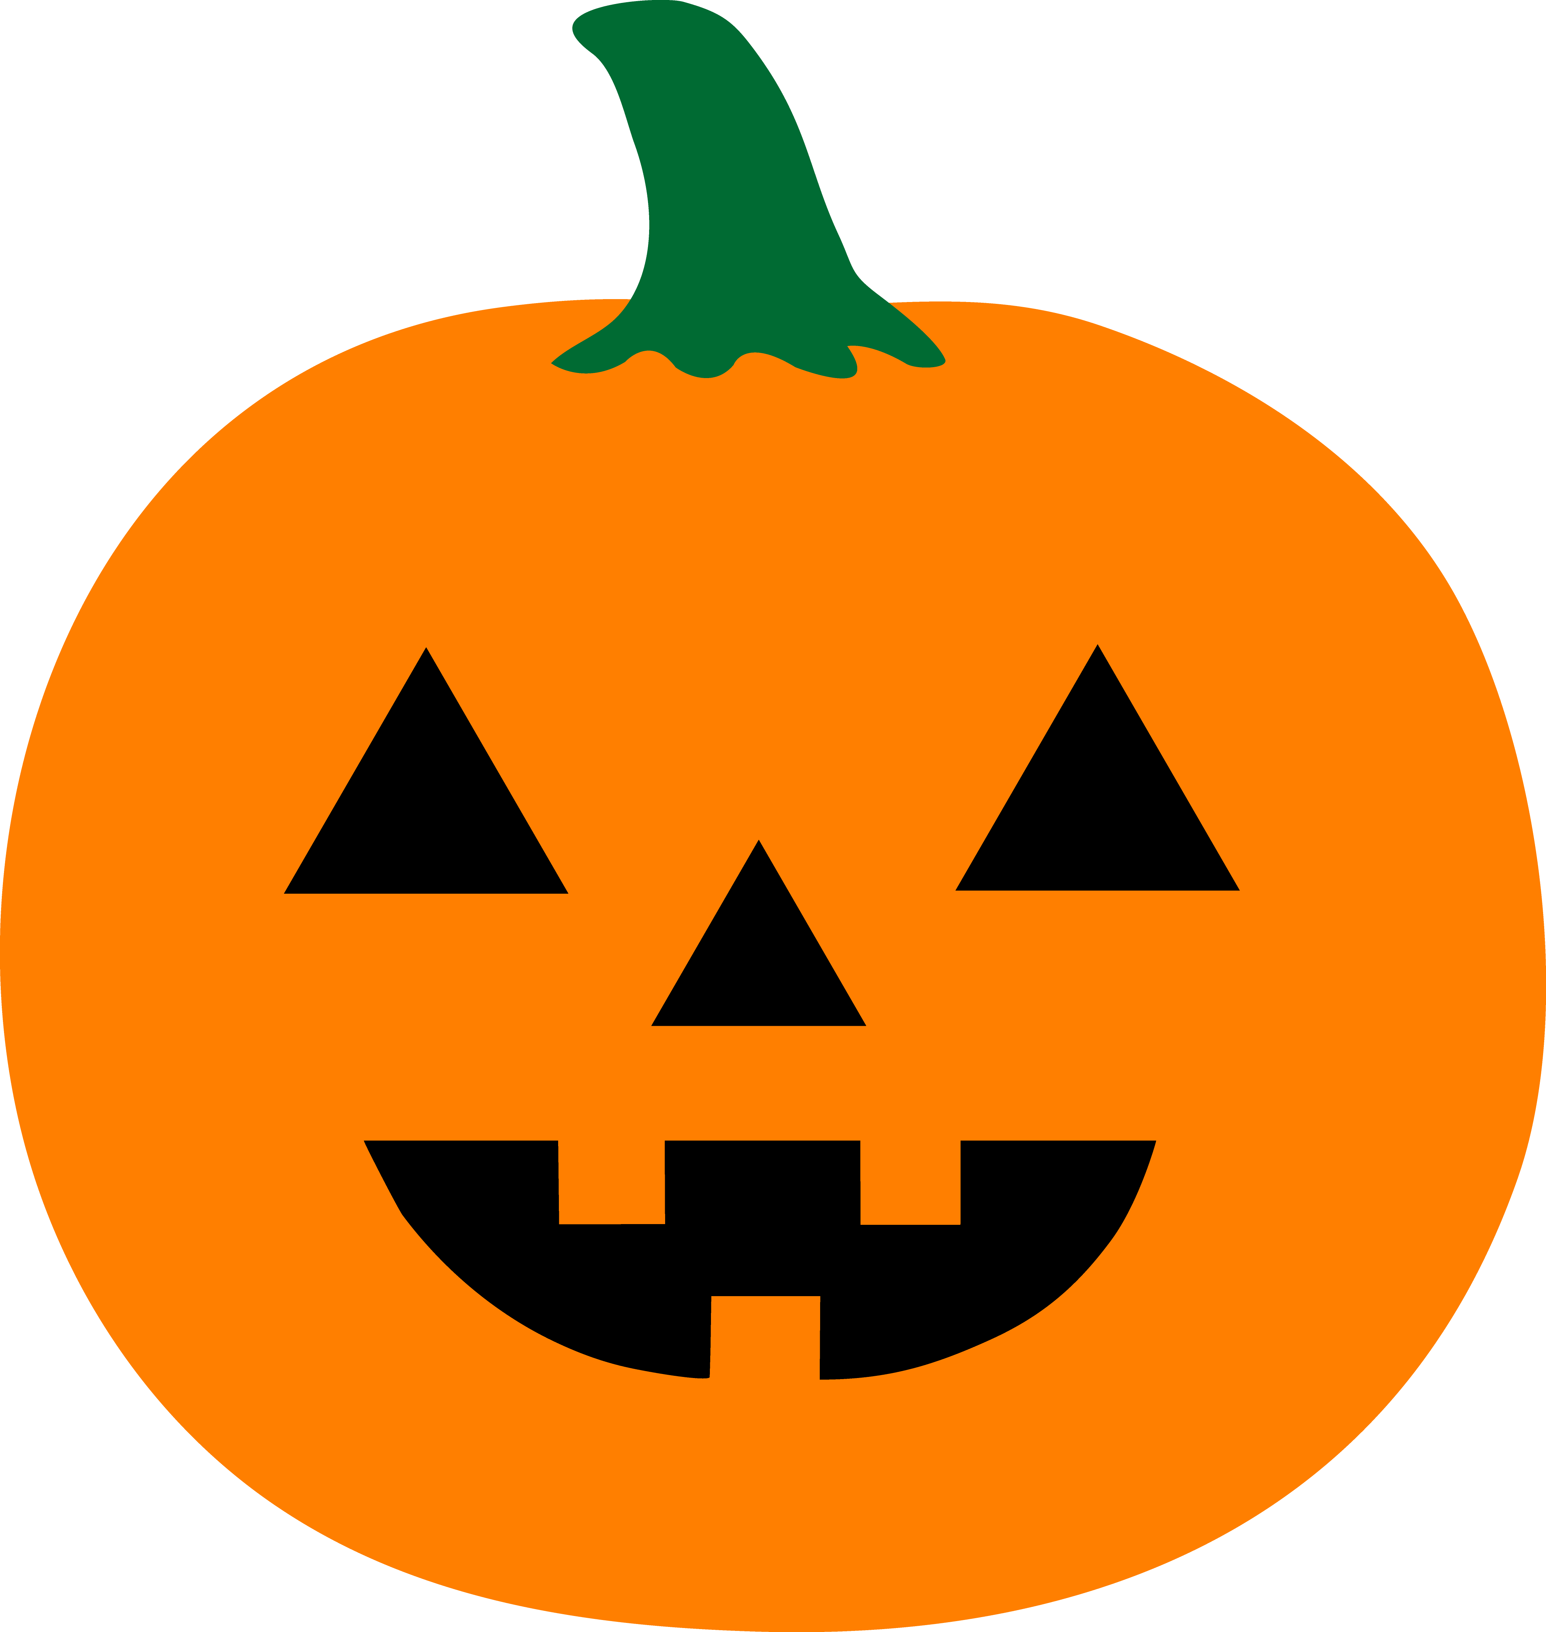

|  | **~ October 2016 ~** | | | | |  |
| --- | --- | --- | --- | --- | --- | --- |
| **Sun** | **Mon** | **Tue** | **Wed** | **Thu** | **Fri** | **Sat** |
| 2    12 pm – 6 pm | 3  3 pm – 7 pm | 4  3 pm – 7 pm | 5  3 pm – 7 pm | 6  3 pm – 7 pm | 7  3 pm – 7 pm | 8  11 am – 7 pm |
| 9  12 pm – 7 pm | 10  3 pm – 7 pm | 11  3 pm – 7 pm | 12  3 pm – 7 pm | 13  3 pm – 7 pm | 14  3 pm – 8 pm | 15  9 am – 8 pm |
| 16  12 pm – 8 pm | 17  1 pm – 8 pm | 18  1 pm – 8 pm | 19  1 pm – 8 pm | 20  1 pm – 8 pm | 21  1 pm – 8 pm | 22  9 am – 8 pm |
| 23  12 pm – 8 pm | 24  11 am – 8 pm | 25  11 am – 8 pm | 26  11 am – 8 pm | 27  11 am – 8 pm | 28  \9 am – 8 pm | 29  9 am – 8 pm |
| 30  12 pm – 8 pm | 31  11 am – 6 pm |  |  |  |  |  |

Mon – Thur 9 am – 2 pm - Go to office on east side of building